Tristan Hoppe, Tim Kartawijaya, Samid Penn

Software Development

24 January 2017

**Project Proposal #1:** User and System Requirements

This report contains a high-level requirements overview for the features used by the Upper Staff user group. A use case diagram and a set of system and user requirements are provided to describe how the feature works and interacts with the Upper Staff.

1. **Use Case Diagram**

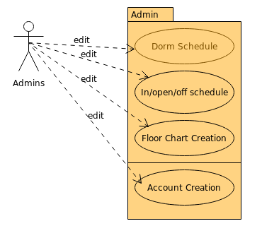

1. **Log-in/Security**

2.1. Upper staff should be able to create and edit their own accounts as well as those of RAs.

2.1.1. The system will store all usernames and passwords for each upper staff account in a database.

2.1.2. The system will allow upper staff to view accounts alphabetical or by searching for them.  
2.1.3. Admin accounts will allow upper staff to view and edit Dorm Schedule, In/Out/Off duty schedule, Floor Charts and other user accounts.

2.1.4. In order for a new account to be valid it must first be approved by an existing admin account.

1. **IN/OPEN/OFF Schedule**
   1. RDs, GRDs and GRAs will be able to access and edit a chart that will show which RAs are and are not available in their rooms and which RAs are off duty.
      1. The system will be able to store all of the schedules and log any changes made on the database.
      2. Each week’s schedule are retrievable by year, month, and week.
      3. The current week’s schedule will be displayed on the main web page for all users, but the other schedules are also retrievable.
      4. Changes to the schedule can be made only by people with admin accounts (RAs and Upper Staff). All other users will only be able to view it.
      5. When the year is over, there is an option to delete all of the past year’s schedules.
2. **Master Schedule** 
   1. This feature will streamline the communication between RA’s and Administrators when they communicate dates for dorm events.
      1. The users would be able to see meeting times, other floor’s raid’s, and campus events.
      2. Administrator staff would be able to edit this calendar and all of the RAs would be able to view it.
      3. It would be stored in the database on a monthly so that the full month would be viewable at any time.
      4. After the year is over, the calendar is flushed.
3. **Floor Chart Creation**
   1. The feature shall generate viewable floor charts and organized data tables when given a roster of students as input, effectively categorizing resident by building and floor.
      1. The system should be able to upload a CSV file containing the resident roster and subset the input into relational data tables which categorizes residents by floor and dorms.
      2. The system should be able to use the data tables to create viewable floor charts and tables for quick reference of who is on a floor/building.
      3. The floor charts and data tables should be downloadable into printer-friendly formats.
      4. Access to this feature will only be accessible to upper staff and RAs.
   2. The user shall be able to retrieve a student’s information from the entire database when searched by their name.
      1. The user should be able to input a name or student ID and prompt a viewer showing where the student lives (building name and room number).
   3. The user shall be able to edit the student roster and effectively update the floor charts and data tables
      1. The user should be able to remove students from the roster.
      2. The user should be able to move/switch students to different rooms, in case of roommate/room changes
      3. The system should provide an interface to add students, requiring input of ID, name, and other important data, in case of transfer students.
      4. The system should give a warning if there is an attempt to add a student to a full room, but allow it if there are forced triples
      5. When a student is added/removed, the floor charts and data tables should be immediately updated.
      6. When an academic year is over, the user should be able to refresh the system with a new set of student